**PART A**

(Part A: TO BE REFERRED BY STUDENTS)

**Experiment No. 02**

**A.1 AIM:**

Study of Basic HTML tags & create homepage for any website using HTML tags.

**A.2 Pre requisite:**

Basic Knowledge of HTML and HTML tags.

**A.3 Tasks**

1. Create an html page named as “: Basic_Html_Tags.html”

Add the following tags detail.

1. Set the title of the page as “Basic Html Tags”

2. Set the different meta tag information(description, author name, keywords, refresh after 10 sec)

3. Moving text = “Basic HTML Tags”

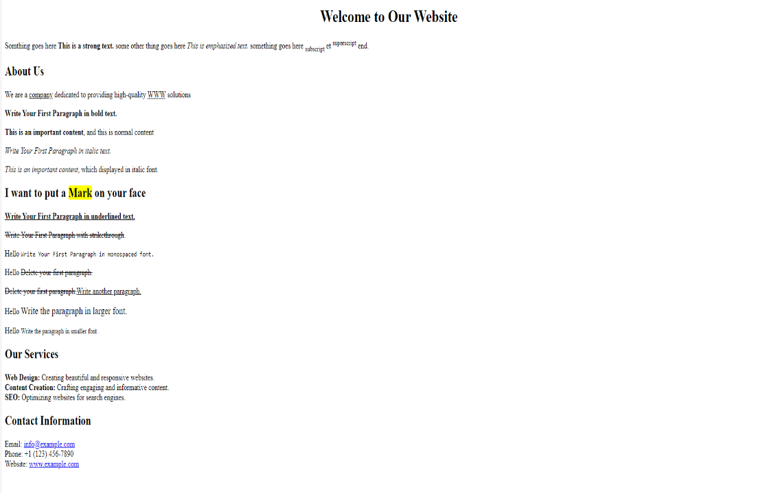

2. a)Design a page having suitable background colour and text colour with title “My First

Web Page” using all the attributes of the meta tag and Font tag.

b) Write HTML code to create a Web Page that contains an Image at its centre.

c) appropriate image towards the left hand side of the page, when user clicks on the image another web page should open.

d)include and audio file and a video file in the page

3. Create an HTML page using tags to accomplish the following:

a) paragraph containing text “All that glitters is not gold”. Bold face and italicize this text

b)Create equation: x = 1/3(y12 + z12 ) and log b m p = p logb m

c)Put a background image to a page and demonstrate all attributes of background image

**A.3.1 Outcome:**

After successful completion of this experiment students will be able to:

1. Design pages in HTML
2. Perform all formatting of text and images in HTML
3. Create lists in HTML

**A.4 Theory:**

**What is HTML?**

HTML is a language for describing web pages. HTML stands for Hyper Text Markup Language. HTML is a markup language. A markup language is a set of markup tags. The tags describe document content. HTML documents contain HTML tags and plain text. HTML documents are also called web pages.

**HTML Tags**

HTML markup tags are usually called HTML tags. HTML tags are keywords (tag names) surrounded by angle brackets like <html>. HTML tags normally come in pairs like <p> and </p>. The first tag in a pair is the start tag, the second tag is the end tag. The end tag is written like the start tag, with a slash before the tag name. Start and end tags are also called opening tags and closing tags

**HTML Element Syntax**

An HTML element starts with a start tag / opening tag. An HTML element ends with an end tag / closing tag. The element content is everything between the start and the end tag. Some HTML elements have empty content. Empty elements are closed in the start tag. Most HTML elements can have attributes.

**HTML Attributes**

HTML elements can have attributes. Attributes provide additional information about an element. Attributes are always specified in the start tag. Attributes come in name/value pairs like: name="value".

Example :

<**html**>

<**head**>

<**title**>This is a title</**title**>

</**head**>

<**body**>

<**p**>Hello world!</**p**>

</**body**>

</**html**>

|  |  |
| --- | --- |
| **Tags** | **Description • Meaning • Definition** |
| **<a>** | ANCHOR tag creates <a href="http://www.fillster.com">[link](http://www.fillster.com/)</a> to other internet location, or file. |
| **<abbr>** | ABBREVIATION tags indicate interpretation of the meaning to the browsers and search engines for such as kind of abbreviations as "Inc.", "etc.". |
| **<acronym>** | ACRONYM tags defines an acronym, like; <acronym title="World Wide Web">**WWW**</acronym>. |
| **<b>** | BOLD tag is specifying <b>**bold section**</b> within the text document. |
| **<big>** | BIG tag makes the <big>**text larger**</big> then the rest of the text. |
| **<body>** | <body> **Body tags identify the content of a web page.**   </body> |
| **<br>** | Line Break tag is specifying<br> **a new line** |
| **<center>** | <center>**CENTER tags center text, images, etc.**</center> |
| **<em>** | EM tags <em>emphasize</em> text. |
| **<fieldset>** | FIELDSET tag creates a form for all elements in it. <fieldset>Find a rounded-corner box around this text.</fieldset> |
| **<font>** | FONT tags attribute text |
| **<form>** | Form tags define a form. |
| **<frame>** | Frame tags define each frame within a frameset. |
| **<frameset>** | FRAMESET tags define a layout of frames. |
| **<h1>to<h6>** | H1 - H6 define level 1-6 headers. |
| **<head>** | Head tags define general information about the document, page title, meta-tags, scripts and links to follow, and other commands to browsers. |
| **<hr>** | HR tag draws a horizontal break line. |
| **<html>** | HTML tags contain HTML elements, and give a command to browsers to read the document as an HTML document. |
| **<iframe>** | iFrame tag creates an inline frame that contains another web page in it. |
| **<img>** | IMG tag attributes an image. |
| **<input>** | INPUT tags define input fields, check boxes, radio buttons. |
| **<i>** | <I> tag is specifying <i>italic text</i>. |
| **<legend>** | LEGEND tag assigns a caption in a fieldset element. |
| **<li>** | LI tag defines a list of ordered and unordered items. |
| **<link>** | LINK tag defines a link to an external document, such as External Style Sheets. |
| **<marquee>** | MARQUEE tags define different movement behaviors. |
| **<option>** | OPTION tag creates a drop-down menu. OPTION tag works only in conjunction with a SELECT tag. |
| **<ol>** | OL tags define an ordered list of items. |
| **<p>** | <p> tag is specifying a paragraph and creates a new line. |
| **<pre>** | PRE tag is specifing a preformatted text. This tag does,t let the browsers to eliminate "white spaces" in the text. |
| **<script>** | SCRIPT tags define scripts within a web page and let the web browsers know that it's not an HTML section. You can place a <SCRIPT> tag anywhere within HTML, but the best practice is to place it between the <HEAD></HEAD> tags. |
| **<select>** | SELECT tag creates a menu on a form. |
| **<small>** | SMALL tag creates a small text. |
| **<strike>** | STRIKE tag creates a strike through words or text. |
| **<strong>** | STRONG tag is specifying a strong text. |
| **<style>** | STYLE tag specifies a link and location to a style sheet, and gives a command to browsers regarding to a layout for a web page. |
| **<sub>** | SUB tag is defining a subscripted text. |
| **<sup>** | SUP tag is defining a superscripted text. |
| **<table>** | TABLE tag is defining a table. |
| **<td>** | TD tag creates a data cell. |
| **<th>** | TH tag creates a header cell. |
| **<tr>** | TR tag creates a row in a table. |
| **<textarea>** | TEXTAREA tag creates a text area. |
| **<title>** | TITLE tag declares a title of an HTML document. |
| **<u>** | U tag makes an underlined text. |
| **<ul>** | UL tags define an unordered list of items. |

**PART B**

(PART B: TO BE COMPLETED BY STUDENTS)

(Students must submit the soft copy as per following segments within two hours of the practical. The soft copy must be uploaded on the Blackboard or emailed to the concerned lab in charge faculties at the end of the practical in case the there is no Black board access available)

|  |  |
| --- | --- |
| Roll No. : C035 | Name: Sukhada Gulhane |
| Class : B | Batch : B2 |
| Date of Experiment : 14-01-2025 | Date/Time of Submission : 14-01-2025 |
| Grade : |  |

**B.1 Code:**

*(Paste your Code here)*

***Task 1:***

<!DOCTYPE html>

<html lang="en">

<head>

    <meta charset="UTF-8">

    <meta name="description" content="Learning Basic HTML Tags">

    <meta name="author" content="Sukhada Gulhane">

    <meta name="keywords" content="HTML, Basics, Meta Tags, Web Design">

    <meta http-equiv="refresh" content="10">

    <title>Basic Html Tags</title>

</head>

<body>

    <marquee>Basic HTML Tags</marquee>

    <h1>Welcome to Basic HTML Tags</h1>

</body>

</html>

***Task 2:***

<!DOCTYPE html>

<html lang="en">

<head>

    <meta charset="UTF-8">

    <meta name="description" content="My First Web Page with Styles">

    <meta name="author" content="Sukhada Gulhane">

    <meta name="keywords" content="HTML, Styles, Web Page">

    <title>My First Web Page (My cats) </title>

    <style>

        body {

            background-color: lightpink;

            color: black;

            font-family: Arial, sans-serif;

        }

        .center {

            display: flex;

            justify-content: center;

            align-items: center;

            height: 50vh;

        }

        .left-image {

            position: absolute;

            left: 0;

            top: 50%;

            transform: translateY(-50%);

        }

    </style>

</head>

<body>

    <h1>My First Web Page (My cats) </h1>

    <div class="center">

        <img src="image.jfif" alt="Centered Image" width="800px" height="500px">

    </div>

    <a href="https://www.google.com">

        <img class="left-image" src="image.jfif" alt="Left Side Image">

    </a>

    <br>

    <audio controls>

        <source src="catmeow.mp3" type="audio/mpeg">

        Your browser does not support the audio element.

    </audio>

    <br><br>

    <video controls width="500">

        <source src="catmeoww.mp4" type="video/mp4">

        Your browser does not support the video element.

    </video>

</body>

</html>

***Task 3:***

<!DOCTYPE html>

<html lang="en">

<head>

    <meta charset="UTF-8">

    <title>HTML Page with Advanced Tags</title>

    <style>

        body {

            background-image: url('image2.jpg');

            background-size: cover;

            background-repeat: no-repeat;

            background-attachment: fixed;

        }

    </style>

</head>

<body>

    <h1><b><i>All that glitters is not gold</i></b></h1>

    <p>

        Equation: x = 1/3(y<sup>12</sup> + z<sup>12</sup>)

    </p>

    <p>

        Equation: log<sub>b</sub>m<sup>p</sup> = p log<sub>b</sub>m

    </p>

</body>

</html>

***Task 4:***

<!DOCTYPE html>

<html lang="en">

<head>

    <meta charset="UTF-8">

    <meta name="viewport" content="width=device-width, initial-scale=1.0">

    <title>Welcome to Our Website</title>

</head>

<body>

    <h1 style="text-align: center;">Welcome to Our Website</h1>

    <p>

        Something goes here <strong>This is a strong text</strong>, some other thing goes here

        <em>This is emphasized text</em>, something goes here

        <u>underlined</u>, something goes here <sup>superscript</sup>,

        and something goes here <sub>subscript</sub> end.

    </p>

    <h2>About Us</h2>

    <p>We are a company dedicated to providing high-quality HTML solutions.</p>

    <p><b>Write Your First Paragraph in bold text.</b></p>

    <p>This is an important content, this is normal content.</p>

    <p><i>Write Your First Paragraph in italics text.</i></p>

    <p>This is an important content, which is displayed in italic font.</p>

    <h2>I want to put a <mark>Mark</mark> on your face</h2>

    <p><u>Write Your First Paragraph in underlined text.</u></p>

    <p><del>Hide Delete your first paragraph.</del></p>

    <p><ins>Write the paragraph in underline paragraph.</ins></p>

    <p>Write the paragraph in larger font.</p>

    <p>Write the paragraph in fine font.</p>

    <h2>Our Services</h2>

    <p><b>Web Design:</b> Creating beautiful and responsive websites.</p>

    <p><b>Custom Creation:</b> Crafting unique and informative content.</p>

    <p><b>SEO:</b> Optimizing websites for search engines.</p>

    <h2>Contact Information</h2>

    <p>Email: <a href="mailto:info@example.com">info@example.com</a></p>

    <p>Phone: +1 (123) 456-7890</p>

    <p>Website: <a href="http://www.example.com" target="_blank">www.example.com</a></p>

</body>

</html>

**B.2 Output**

*(Take screen shots of the output at run time and paste it here)*

***Task 1:***

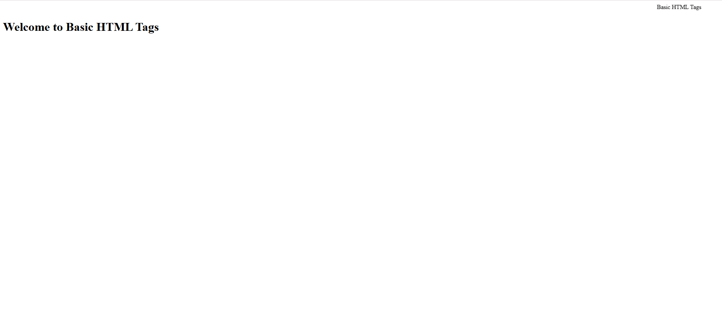

***Task 2:***

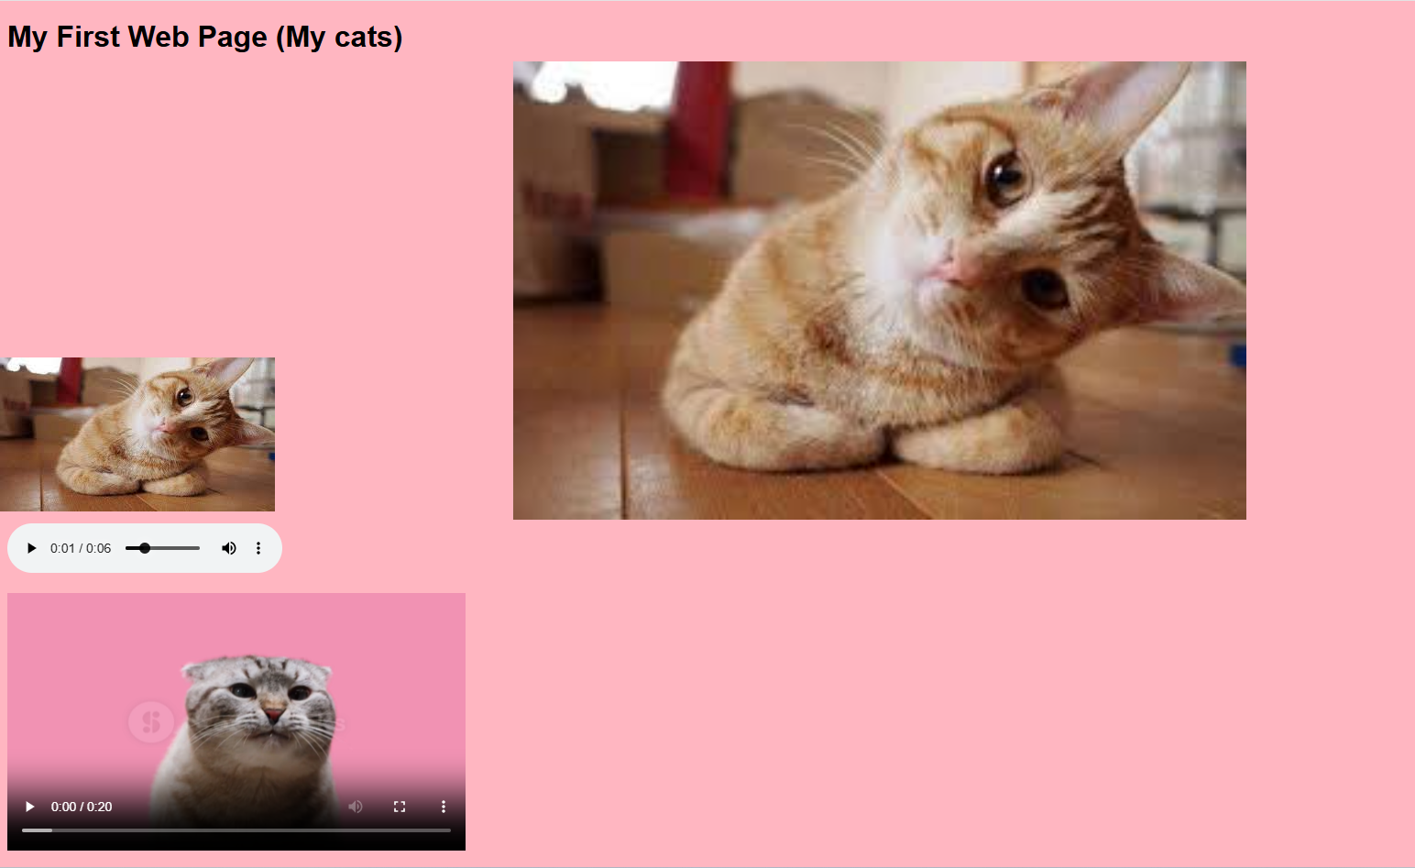

***Task 3:***



***Task 4:***

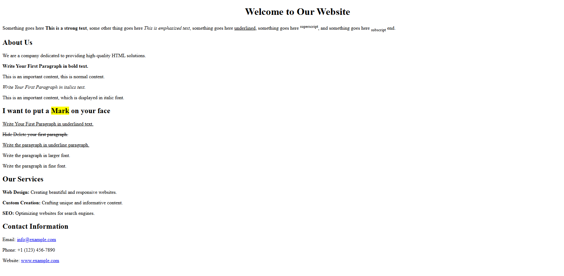

**B.3 Conclusion:**

*(Students must write the conclusion as per the attainment of individual outcome listed above)*

In this experiment, I learned the practical application of basic HTML tags, including structural elements (like <html>, <head>, <body>), formatting tags (like <b>, <i>, <sup>, <sub>), and multimedia integration tags (like <audio> and <video>). By combining these tags, I successfully created a functional and visually appealing web page. This activity enhanced my understanding of web development fundamentals and improved my ability to use HTML effectively to meet specific design requirements.

**B.3 Observations and Learning:**

*(Students must write their observations and learnings as per the attainment of individual outcome listed above)*

**Observations:**

The <marquee> tag can be used to create a scrolling text effect, but it is considered outdated and may not work in all modern browsers.

Multimedia elements like <audio> and <video> are simple to integrate and provide interactive features like playback controls.

Background images enhance the visual appeal of a web page but require careful attention to contrast for readability.

**Learning:**

Learned how to use the <meta> tag to provide metadata, including refreshing the page automatically after a specific time.

Understood the use of structural and semantic tags to organize content logically.

Gained experience in applying inline styles and the <style> tag for CSS-based customization of appearance

**B.4 Question of Curiosity**

*(To be answered by student based on the practical performed and learning/observations)*

Q.1. Describe all basic tags used by you in the above experiment with syntax and an example.

Ans:

* **<html>**: Defines the root element.  
  Example: <html>Content here</html>
* **<head>**: Contains metadata.  
  Example: <head><title>Title</title></head>
* **<title>**: Sets the browser tab title.  
  Example: <title>Basic HTML Tags</title>
* **<body>**: Contains visible content.  
  Example: <body><h1>Welcome</h1></body>
* **<h1> to <h6>**: Headings, <h1> largest, <h6> smallest.  
  Example: <h1>Heading</h1>
* **<p>**: Paragraphs.  
  Example: <p>This is a paragraph.</p>
* **<b> & <i>**: Bold and italic.  
  Example: <p><b>Bold</b> <i>Italic</i></p>
* **<sup> & <sub>**: Superscript and subscript.  
  Example: x<sup>2</sup> + y<sub>3</sub>
* **<audio> & <video>**: Embeds audio and video.  
  Example: <audio controls><source src="file.mp3"></audio>
* **<img>**: Embeds an image.  
  Example: <img src="image.jpg" alt="Description">
* **<a>**: Hyperlink.  
  Example: <a href="https://example.com">Click Here</a>
* **<marquee>**: Scrolling text (deprecated).  
  Example: <marquee>Scrolling Text</marquee>